Dart Programming Lab 1 (Output)
REGNO: -223006785
-223021337
Part1.
Question1:
Question2:
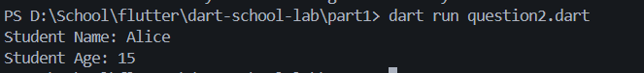
Question3:
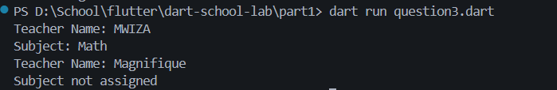
Part2:
Question 1 & 2

Part 3
Question 1 &2
Part 4
Question 1 & 2
Part 5
Question 1 & 2
Part 6
Question 1 & 2
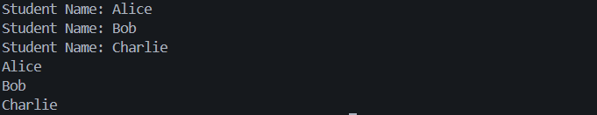
Part 7
Question 1
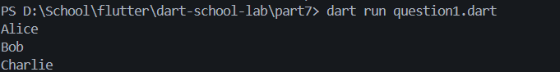
Question 2
Part 8
Question 1 & 2
Part 9
Question 1
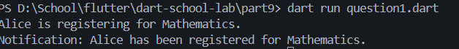
Part 9
Question 1

